

Eliza, Fatim, Noora ja Joanna

Joanna:

Eliza:

Noora:

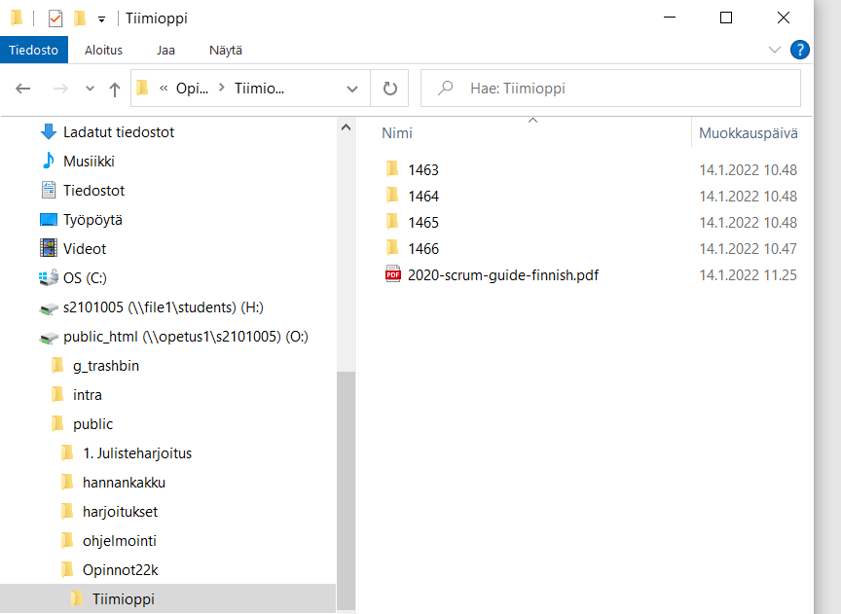

Fatim: